|  |
| --- |
| IMY 320 Project Plan |
|  |
| Nicole Hampshire 14015341 Kezia Kokosioulis 14081360 Janko Lilje 14049172 |

# Project Requirements:

## Website:

* Front page: Display events, stories and news.
* Contact us / About us page.
* Calendar: Display what events are planned.
* Login System.
* Admins can post articles (news, stories and events).
  + Events: Facebook event information and work groups for each event (Admin, décor, PR, etc – Ability to make mass announcements to each work group and assign members to a specific work group).
* Store official documents (files, music).

## Mobile Application:

* Members must be able to read news
* View calendar.
* Login system for members.
* Announcement function to everyone who has the application.

# Project

## Colour Scheme and Design:

Neutral Colour scheme with Proudly South African accent colours

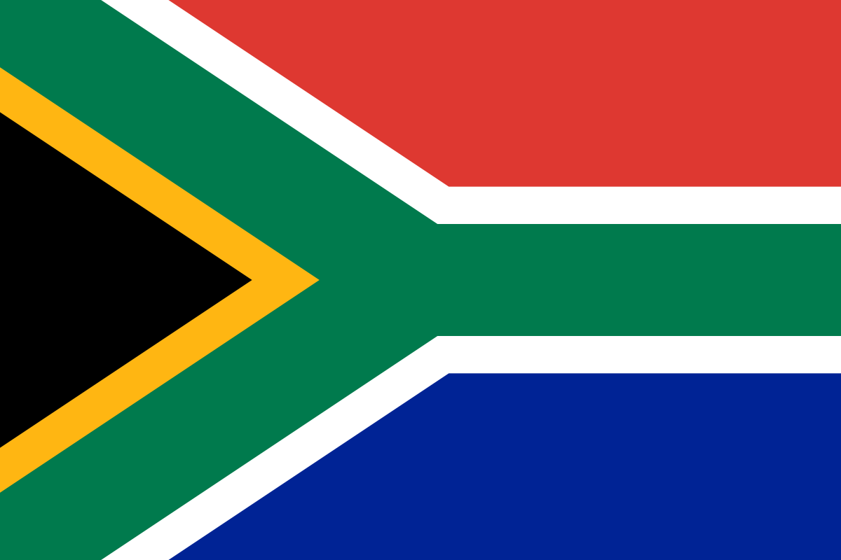

Simple, elegant and professional design.

## Layout:

Large screen:

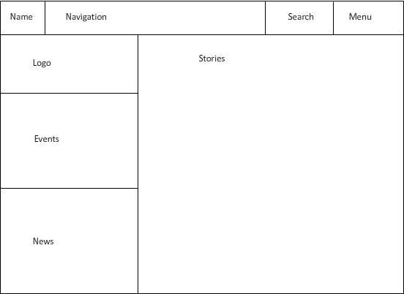

Small screen:

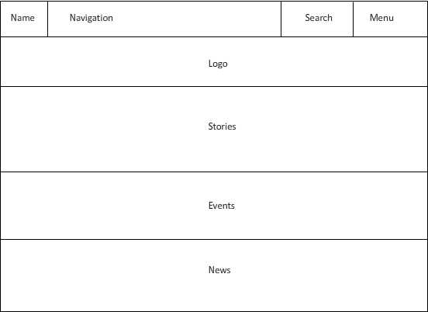

Menu:

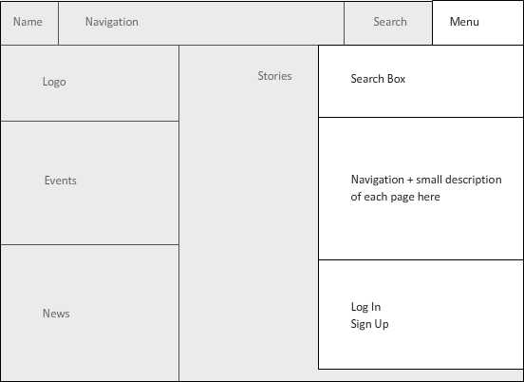

Login and Sign Up:

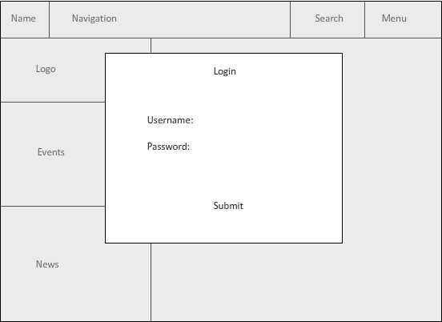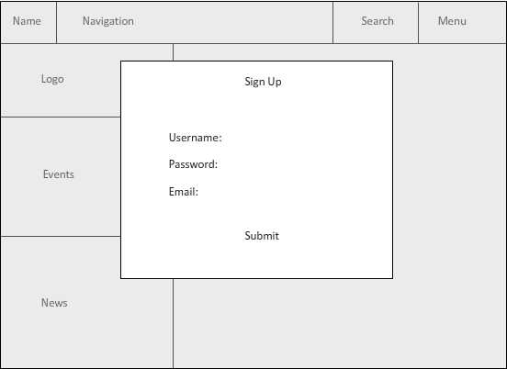

Events:

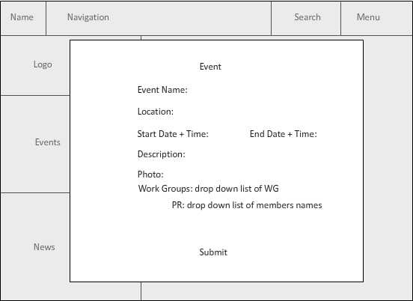

Stories:

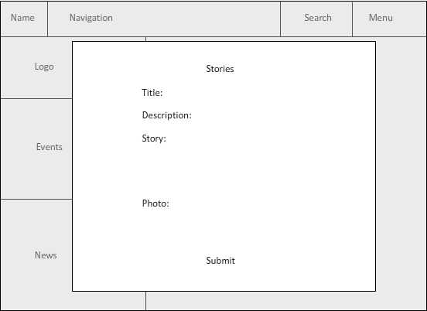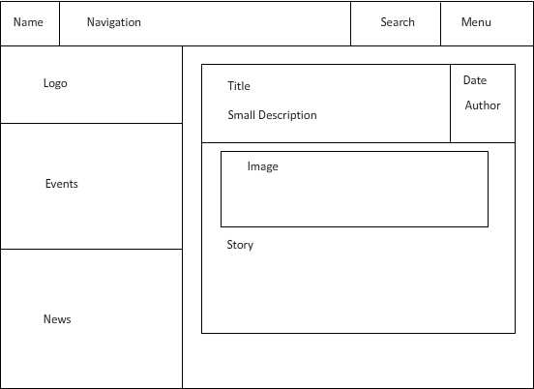

News:

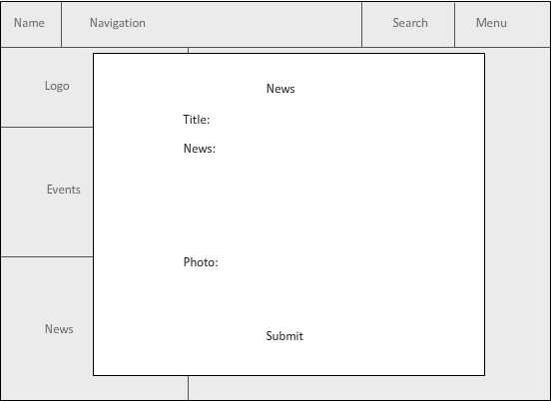

Mobile:

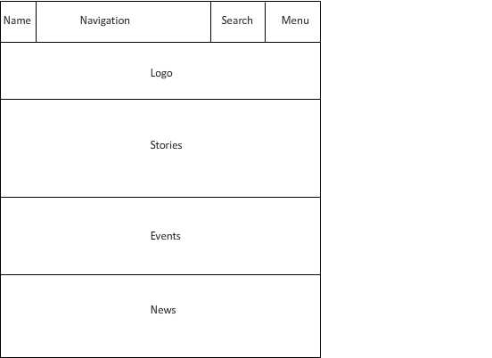

Mobile Story Layout:

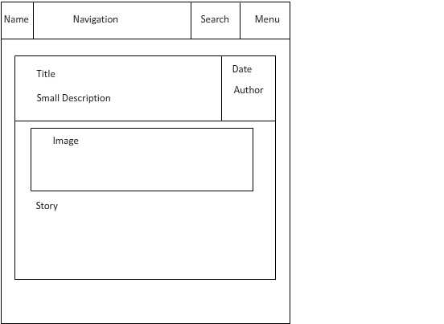

Calendar:

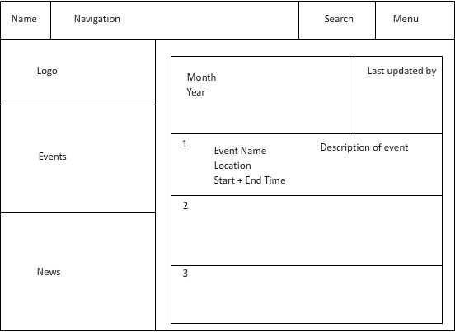

## Technologies:

Login and Sign Up system

* PHP and SQL.
* A database will be used to manage members and admins.
* ID (Unique to each member), Username, Email, Password, Photo, Admin (Yes/No), EventID (The ID of the event that they are currently involved in), Work Group (Their role in the event).

Event System

* PHP and SQL.
* A database will be used to manage the events that are occurring.
* ID (Unique to each event), Name, Location, Start Date + Time, End Date + Time, Description, Photo.

News and Stories:

* PHP and SQL.
* A database will be used to manage the news and stories that have been posted.
* News: ID, Title, News, Photo.
* Story: ID, Title, Description, Story, Photo.

Other – HTML 5, jQuery, JavaScript, Sass.